**REPORT**

The liquor consumption and liquor retail chain state of Iowa

**April 2024**

**Author** Maria Orlova

**Introduction**

I used a public dataset "Iowa Liquor Retail Sales" from Big Query to explore the liquor retail chain in the state and find out how consumption and sales changed during 2012-2023 years.

The report includes:

1. A statement of the business task

2. A description of all data sources used

3. Documentation of any cleaning or manipulation of data

4. A summary of analysis

5. Supporting visualizations and key findings

**1. A statement of the business task**

|  |
| --- |
| Find out how consumption and sales changed during 2012-2023 years and explore the liquor retail chain in the state of Iowa in 2023. |

**2. A description of all data sources used**

The dataset "Iowa Liquor Retail Sales" contains every wholesale purchase of liquor in the State of Iowa by retailers for sale to individuals since January 1, 2012. The State of Iowa controls the wholesale distribution of liquor intended for retail sale, which means this dataset offers a complete view of retail liquor sales in the entire state. The dataset contains every wholesale order of liquor by all grocery stores, liquor stores, convenience stores, etc., with details about the store and location, the exact liquor brand and size, and the number of bottles ordered.

This public dataset is hosted in Google BigQuery and is included in BigQuery's 1TB/mo of free tier processing. This means that each user receives 1TB of free BigQuery processing every month, which can be used to run queries on this public dataset.

The data is available from the State of Iowa's Alcoholic Beverages Division, within the Iowa Department of Commerce.

The dataset includes one table called "sales". The table "sales" (bigquery-public-data.iowa_liquor_sales.sales) has 24 fields.

There aren’t any issues with bias or credibility in this data. The data is reliable, original, comprehensive, current and cited.

**3.** [**Documentation of any cleaning or manipulation of data**](https://docs.google.com/spreadsheets/d/1KLRyR67ogYaW0QpbZ2CWnraYlVrl49d7aEevBZAmpoU/edit?usp=sharing)

(https://docs.google.com/spreadsheets/d/1KLRyR67ogYaW0QpbZ2CWnraYlVrl49d7aEevBZAmpoU/edit?usp=sharing)

**4.** [**A summary of analysis**](https://docs.google.com/spreadsheets/d/1HO7xrqUcLq4kZzlNgGLTZFgwPGt_uRe1opz1NiYKMBw/edit?usp=sharing)

(https://docs.google.com/spreadsheets/d/1HO7xrqUcLq4kZzlNgGLTZFgwPGt_uRe1opz1NiYKMBw/edit?usp=sharing)

**5. Supporting visualizations and key findings**

**5. 1. How did consumption and sales of liquor change during 2012-2023 years in the state of Iowa?**

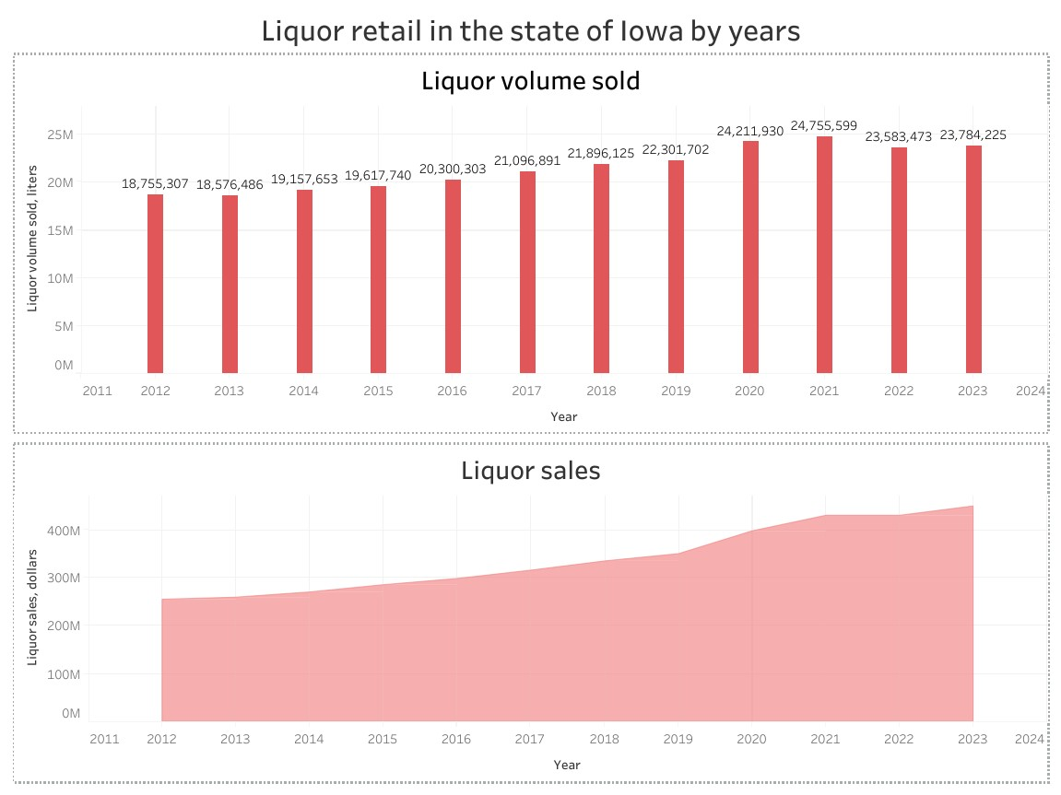

|  |
| --- |
| We could notice that the volume of liquor sold increased from 2012 to 2021 years and then there was a small decrease. The greatest liquor volume was sold in the 2021 year (24.8 million liters) and in the 2020 year (24.2 million liters). It might be related to the pandemic COVID-19 which caused an increase in liquor consumption.  The sales of liquor were increasing from over 255 million to over 488 million during 2012-2023[1]. The growth rate for the whole period was 75.7 %.  Let's compare the growth rate of liquor volume sold (this indicator better shows the consumption of the liquor) and the population state of Iowa. The population of Iowa in 2012 year was 3076844 people, in 2023 years it was 3207004 people[2]. The growth rate of the population between 2012 and 2023 was 4.23 %. The growth rate of the liquor sold was 26.8 % between 2012 and 2023. So, the growth rate of liquor sold was much higher than the growth rate of the population. Particularly, it might be an influence of developing tourism in the state of Iowa, not only consumption increasing. Because the number of visitors and the economic impact of tourism in Iowa are growing[3]. |

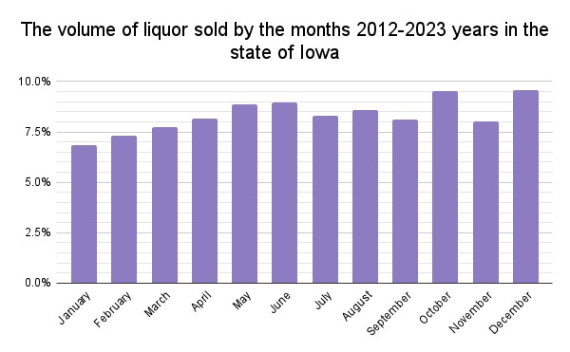

|  |
| --- |
| I worked the pivot table "Pivot_table_Volume_by_months" to explore how the volume sold was changed by the months. I used column N "Grand Total", and I counted each monthly volume sold in percentage to year volume sold. The most liquor volume was sold in October (9.6 %), December (9.5 %), June (9.0 %), and May (8.9 %) during the 2012-2023 years. Probably, it was related to state holidays (Christmas Day, Memorial Day, Independence Day) and vacations. |

**5. 2. The retail liquor chain of Iowa in the year 2023**

|  |  |  |  |  |  |
| --- | --- | --- | --- | --- | --- |
| County | Number_of_stores | Total_volume_sold, liters | Total_volume_sold, % | Total_sale, dollars | Total_sale, % |
| POLK | 285 | 5175428 | 21.8% | 106102363 | 23.7% |
| LINN | 150 | 2024955 | 8.5% | 37765377 | 8.4% |
| BLACK HAWK | 96 | 1209233 | 5.1% | 22716085 | 5.1% |
| SCOTT | 96 | 1484629 | 6.2% | 28251487 | 6.3% |
| JOHNSON | 86 | 1330987 | 5.6% | 25698105 | 5.7% |
| POTTAWATTAMIE | 63 | 819449 | 3.4% | 16364116 | 3.7% |
| DUBUQUE | 59 | 701542 | 2.9% | 12230653 | 2.7% |
| WOODBURY | 56 | 803902 | 3.4% | 15442582 | 3.4% |
| STORY | 53 | 669452 | 2.8% | 12374665 | 2.8% |
| DALLAS | 43 | 660393 | 2.8% | 14043358 | 3.1% |
| DES MOINES | 39 | 260355 | 1.1% | 4966658 | 1.1% |
| CLINTON | 32 | 606948 | 2.6% | 11818078 | 2.6% |

|  |
| --- |
| Now, let's have a concise description of the retail liquor chain of Iowa in the year 2023.  • 2110 stores sold liquor for 99 counties.  • Over 50 stores sold liquor in Polk, Linn, Black Hawk, Scott, Johnson, Pottawattamie, Dubuque, Woodbury, and Story counties. These counties and Dallas and Clinton sold more than 600 thousand liquor liters and had sales of liquor more than 10 million dollars. |

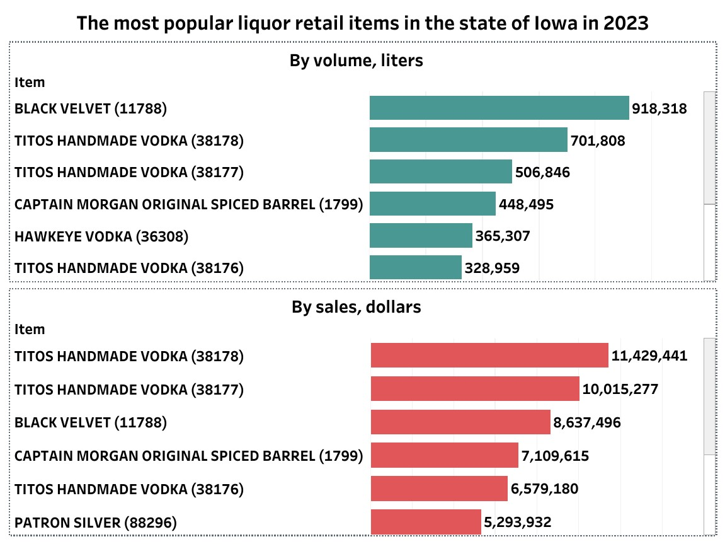

|  |
| --- |
| In the liquor retail of Iowa were 48 liquor items. The most popular liquor items by liquor volume sold and sales were Titos Handmade Vodka, Black Velvet, and Captain Morgan Original Spiced Barrel. |

|  |  |  |  |
| --- | --- | --- | --- |
| Vendor_number | Vendor_name | Total_volume_sold, liters | Total_sale, dollars |
| 421 | SAZERAC COMPANY INC | 4797991 | 67495726 |
| 260 | DIAGEO AMERICAS | 3526069 | 89307275 |
| 259 | HEAVEN HILL BRANDS | 2286744 | 27710406 |
| 434 | LUXCO INC | 1763922 | 16161680 |
| 301 | FIFTH GENERATION INC | 1632634 | 30916702 |
| 65 | JIM BEAM BRANDS | 1497517 | 30136459 |
| 370 | PERNOD RICARD USA | 1075711 | 27770388 |
| 395 | PROXIMO | 865937 | 15716709 |
| 35 | BACARDI USA INC | 807979 | 22700318 |
| 85 | BROWN FORMAN CORP. | 598352 | 20593538 |

|  |
| --- |
| 250 vendors delivered liquor in the state of Iowa in 2023.  More than 800 thousand liters were ordered from Sazerac Company Inc, Diageo Americas, Heaven Hill Brands, Luxco Inc, Fifth Generation Inc, Jim Beam Brands, Pernod Ricard Usa, Proximo, Bacardi Usa Inc. These nine vendors delivered 77% of liquor volume in 2023.  Liquor sales of more than 20 million were made by such vendors as Sazerac Company Inc, Diageo Americas, Heaven Hill Brands, Fifth Generation Inc, Jim Beam Brands, Pernod Ricard Usa, Bacardi Usa Inc, Brown Forman Corp. |

1. https://docs.google.com/spreadsheets/d/1HO7xrqUcLq4kZzlNgGLTZFgwPGt_uRe1opz1NiYKMBw/edit?usp=sharing
2. [United States Census Bureau](https://www.census.gov/glossary/#term_Populationestimates)
3. https://www.legis.iowa.gov/docs/publications/DF/1444381.pdf